Operating Systems Lab

Dipesh Singh – 190905520

Question 1 : Write a multithreaded program that generates Fibonacci series.

Source Code :

#include <stdio.h>
#include <stdlib.h>
#include <pthread.h>

void* thread_code(void* args){
int *arr = (int*)args;
int n = arr[0];
arr[1] = 0;
arr[2] = 1;
for(int i = 3; i<=n; i++){
arr[i] = arr[i-1] + arr[i-2];
}
}

int main(int argc, char* argv[]){
if(argc<2){
printf("Not enough arguments!\n");
exit(EXIT_FAILURE);
}
int n = atoi(argv[1]);
int* arr = (int*)calloc(n+1, sizeof(int));
arr[0] = n;
pthread_t thread;
pthread_create(&thread, 0, &thread_code, (void*)arr);
pthread_join(thread, 0);
printf("The fibonacci series is : ");
for(int i = 1; i<=n; i++){
printf("%d ", arr[i]);
}
printf("\n");
return 0;
}

Output :

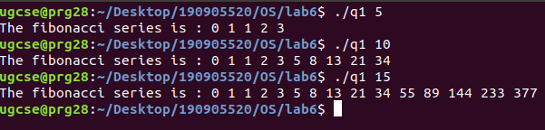

Question 2 : Write a multithreaded program that calculates the summation of non-negative integers in a seperate thread and passes the result to the main thread.

Source Code :

#include <stdio.h>
#include <stdlib.h>
#include <pthread.h>

void* thread_code(void* args){
int *arr = (int*)args;
int n = arr[0];
int *res = (int*) malloc (sizeof(int));
*res = 0;
for(int i = 1; i<=n; i++){
*res+=arr[i];
}
return (void*)res;
}

int main(int argc, char* argv[]){
if(argc<2){
printf("Not enough arguments!\n");
exit(EXIT_FAILURE);
}
int n = argc - 1;
int* arr = (int*)calloc(n+1, sizeof(int)), *res;
arr[0] = n;
for(int i = 0; i<n; i++){
arr[i+1] = atoi(argv[i+1]);
}
pthread_t thread;
pthread_create(&thread, 0, &thread_code, (void*)arr);
pthread_join(thread, (void**)&res);
printf("The sum is : %d\n", *res);
return 0;
}

Output :

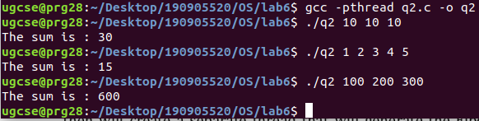
Question 3 : Write a multithreaded program for generating prime numbers from a given starting number to the given ending number.

Source Code :

#include <stdio.h>
#include <stdlib.h>
#include <pthread.h>

void* thread_code(void* args){
int *arr = (int*)args;
int lower_limit = arr[0];
int upper_limit = arr[1];
int *sieve = (int*) calloc (upper_limit+1, sizeof(int));
for(int i = 0; i<=upper_limit; i++){
sieve[i] = 1;
}
sieve[0] = 0;
sieve[1] = 0;
for(int i = 2; i*i<=upper_limit; i++){
if(sieve[i] == 1){
for(int j = i*i; j<=upper_limit; j+=i){
sieve[j] = 0;
}
}
}
return (void*)sieve;
}

int main(int argc, char* argv[]){
if(argc<3){
printf("Not enough arguments!\n");
exit(EXIT_FAILURE);
}
int lower_limit = atoi(argv[1]);
int upper_limit = atoi(argv[2]);
int packet[] = {lower_limit, upper_limit}, *result;
pthread_t thread;
pthread_create(&thread, 0, &thread_code, (void*)packet);
pthread_join(thread, (void**)&result);
printf("The prime numbers are : ");
for(int i = lower_limit; i < upper_limit; i++){
if((result)[i])
printf("%d ", i);
}
printf("\n");
return 0;
}

Output :

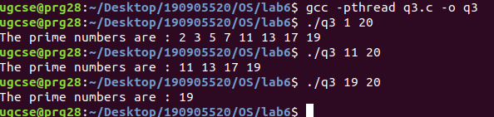
Question 4 : Write a multithreaded program that performs the sum of even numbers and odd numbers.

Source Code :

#include <stdio.h>
#include <stdlib.h>
#include <pthread.h>

void* add_odd(void* args){
int *arr = (int*)args;
int n = arr[0];
int *res = (int*) malloc (sizeof(int));
*res = 0;
for(int i = 1; i<=n; i++){
if(arr[i]&1)
*res+=arr[i];
}
return (void*)res;
}

void* add_even(void* args){
int *arr = (int*)args;
int n = arr[0];
int *res = (int*) malloc (sizeof(int));
*res = 0;
for(int i = 1; i<=n; i++){
if(!(arr[i]&1))
*res+=arr[i];
}
return (void*)res;
}

int main(int argc, char* argv[]){
if(argc<2){
printf("Not enough arguments!\n");
exit(EXIT_FAILURE);
}
int n = argc - 1;
int* arr = (int*)calloc(n+1, sizeof(int)), *res_even, *res_odd;
arr[0] = n;
for(int i = 0; i<n; i++){
arr[i+1] = atoi(argv[i+1]);
}
pthread_t thread_odd, thread_even;
pthread_create(&thread_odd, 0, &add_odd, (void*)arr);
pthread_create(&thread_even, 0, &add_even, (void*)arr);
pthread_join(thread_odd, (void**)&res_odd);
pthread_join(thread_even, (void**)&res_even);
printf("The sum of odd is : %d\n", *res_odd);
printf("The sum of even is : %d\n", *res_even);
return 0;
}

Output :

